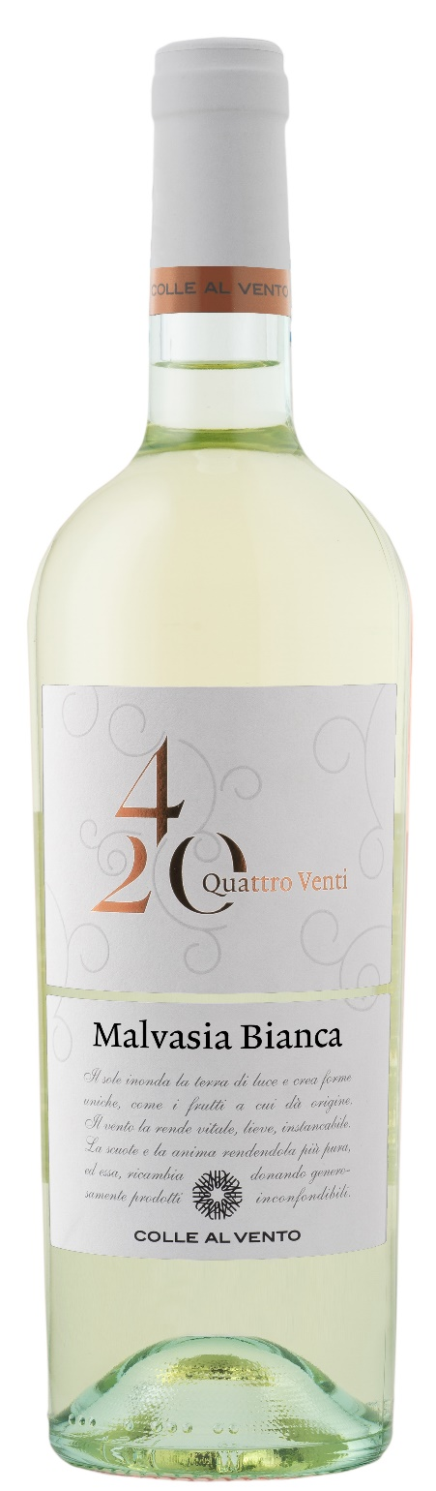
MALVASIA BIANCA IGP – 4/20

Grape: Malvasia 100%
Alc. Vol.%: 12,5
Vintage: 2024
Residual sugar g/l: 8,3
Total acidity g/l: 6,2
Region: Apulia
Capacity: 750ml

CHARACTERISTICS

Vinification: Maceration of the must with the berry skins at 0°, then separation and fermentation at a controlled temperature
Aging: In steel tanks until bottling
Yield per ha: 14000kg
Colour: Bright white with greenish reflections
Bouquet: Pleasant citrus and flowery notes
Flavour: Fresh and balanced

SERVING SUGGESTIONS

Light starters and fish dishes, but also light meat dishes such as grilled chicken breast.
Serving temperature 6-8 °C
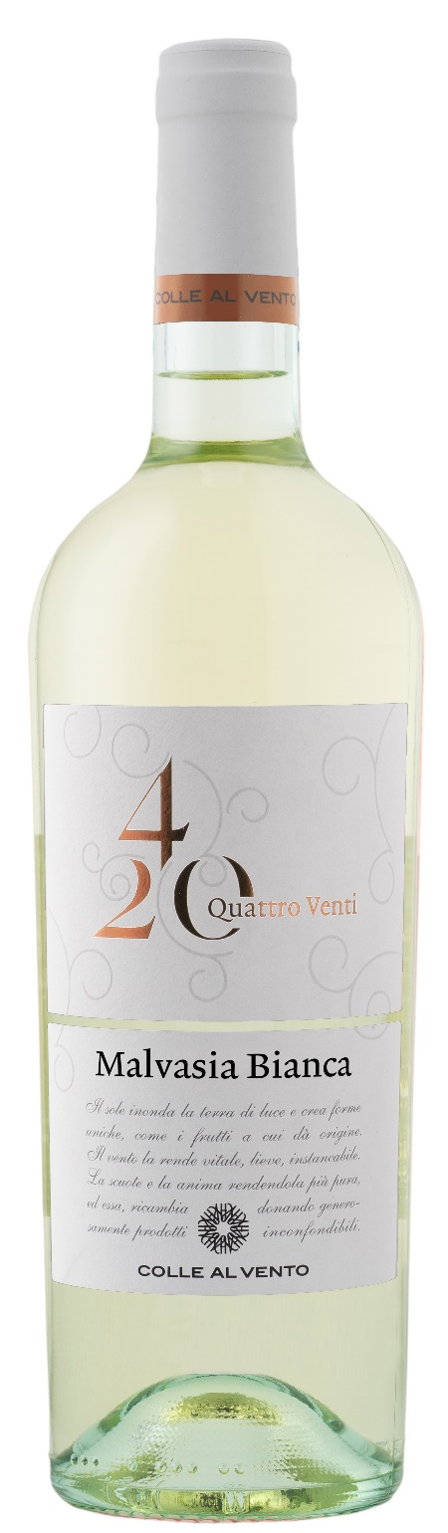
TECHNICAL INFORMATION / PALLETIZING

Size 750ml:
Article Nr. V03020A
GTIN-13 bottle 8017868006367
GTIN-13 carton 8017868006374
Closure Cork
Bottles / carton 6 bottles
Pallet size 80x120cm
Cartons/layer 21
Cartons/pallet 105
Kg/carton 7,8
Kg/pallet 840

Contains sulphites
GMO Free
Revisione 01. 10.04.2025

